* After database creation resource group will have a database and a server in its resource section 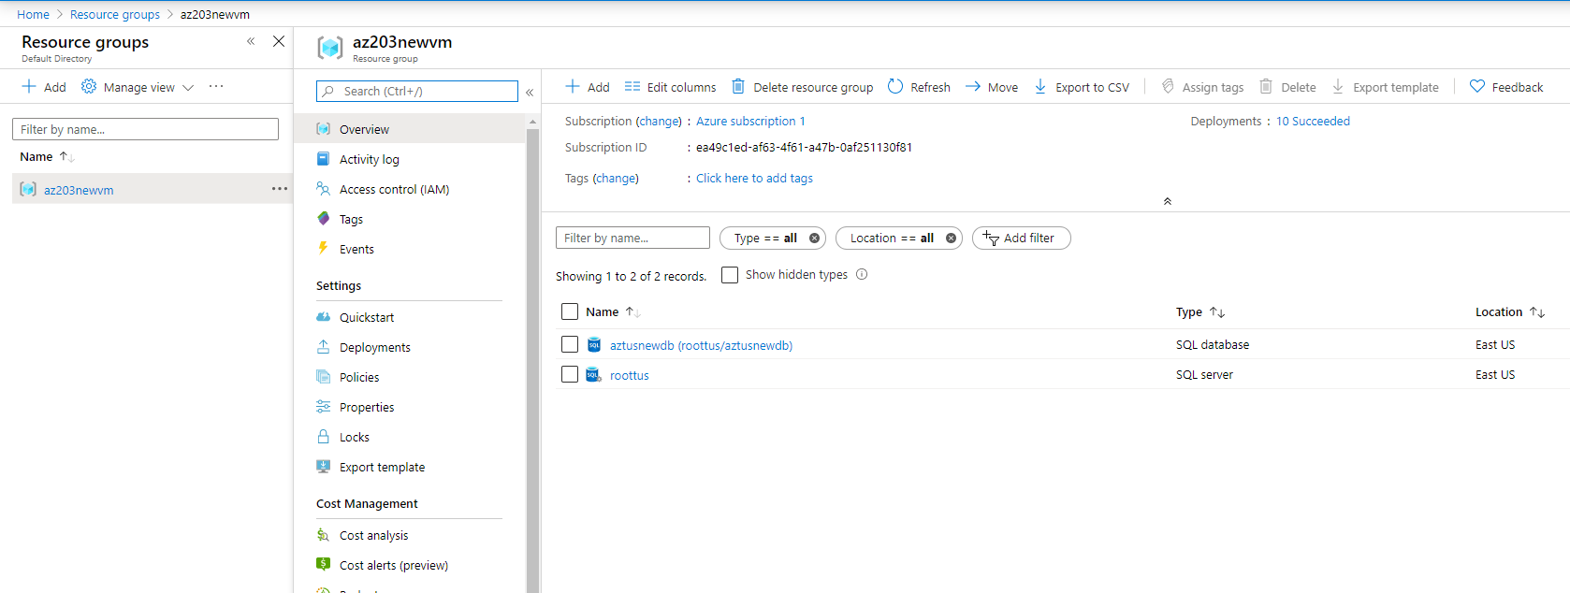
* Check the deployments in deployment section of resource groups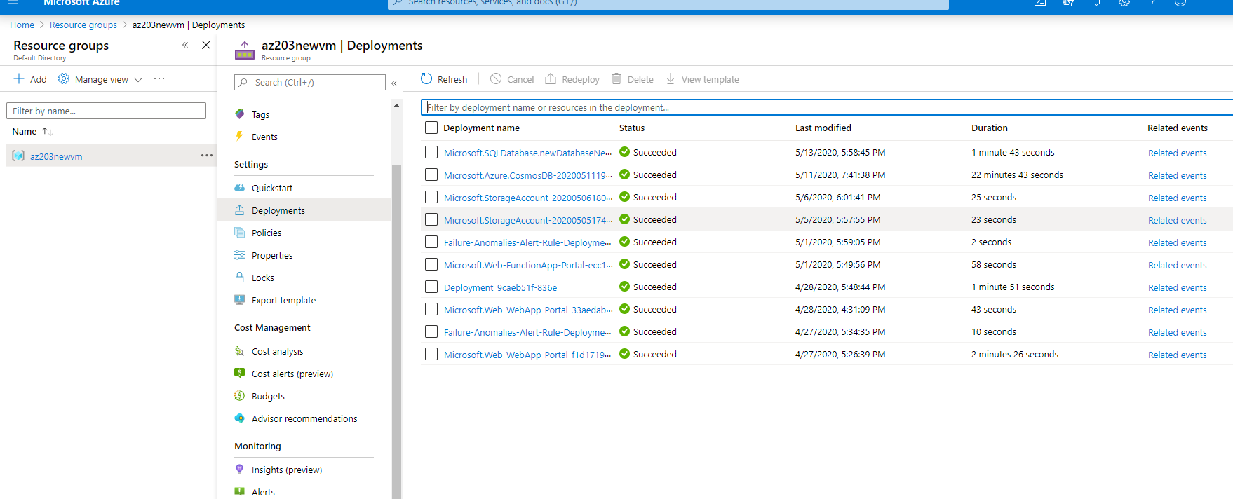
* If resource utilization is coming around 100% then you may want to consider increasing the pricing tier of database.
* Geo-Replication can be setup on the database page Geo-replication Tab. 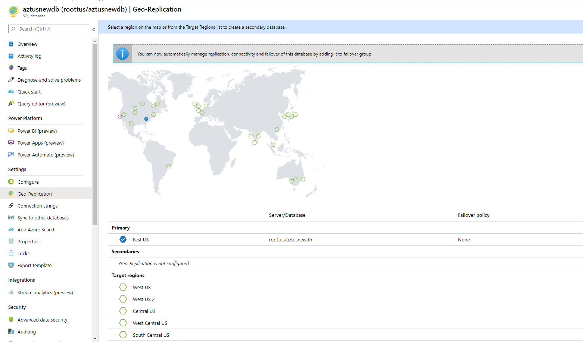
* Can select the region from below in which you wish to replicate your data. You have to create a new server though.
* It which be your choice of region as closer region for data availability will provide low latency for users.
* Other benefit of it is failure of a specific region.
* We can switch for the fail over b/w the databases.